NATIONAL UNIVERSITY OF MODERN LANGUAGE ISLAMABAD
Lab 06


Submitted to:
Ms. Fatima Gillani
Submitted by:
Zulqarnain Hassan
Roll No: …………………… SP21379
Subject: …………………… SCD
Department: ……………… BSSE-5-Afternoon
Date: ……………………… 25-10-2024

Task 01
1. Implement Zakat Calculator using Naming conventions and follow snake case Notation as
Standard
package lab_5;
import java.util.Scanner;

public class ZakatCalculator {

public static void main(String[] args) {
Scanner scanner = new Scanner(System.in);

double ZAKAT_RATE = 0.025;
double GOLD_NISAB = 87.48;
double SILVER_NISAB = 612.36;
double goldPricePerGram = 24049.67;
double silverPricePerGram = 307.79;

// Get user inputs
System.out.println("Enter the weight of gold you own (in grams): ");
double goldWeight = scanner.nextDouble();

System.out.println("Enter the weight of silver you own (in grams): ");
double silverWeight = scanner.nextDouble();

System.out.println("Enter the amount of cash you own RS: ");
double cash = scanner.nextDouble();

// Calculate total value of gold, silver, in cash
double goldValue = goldWeight * goldPricePerGram;
double silverValue = silverWeight * silverPricePerGram;

//check for zakat eligibility
if (goldWeight>GOLD_NISAB) {
System.out.println("\n\nYou are eligible for zakat on gold.");
System.out.println("Your zakat amount is: RS" + goldValue*ZAKAT_RATE);
}
else {
System.out.println("\n\nYou are not eligible for zakat on gold.");

}
if (silverWeight>SILVER_NISAB) {
System.out.println("\n\nYou are eligible for zakat on silver.");
System.out.println("Your zakat amount is: RS" + silverValue*ZAKAT_RATE);
}
else {

System.out.println("\n\nYou are not eligible for zakat on silver.");
}
if (cash>147300) {
System.out.println("\n\nYou are eligible for zakat on cash.");
System.out.println("Your zakat amount is: RS" + cash*ZAKAT_RATE);
}
else {

System.out.println("\n\nYou are not eligible for zakat on cash.");
}

//for overall wealth
double totalWealth = goldValue + silverValue + cash;
if(silverWeight<SILVER_NISAB && goldWeight<GOLD_NISAB && cash<1473000) {
if(totalWealth>=1473000) {
System.out.println("\n\nYou are eligible for zakat on total wealth.");
System.out.println("Your zakat amount on total wealth is: RS" + totalWealth*ZAKAT_RATE);
}
else {
System.out.println("\n\nYou are not even eligible for zakat on your whole wealth.");
}
}
scanner.close();
}
}

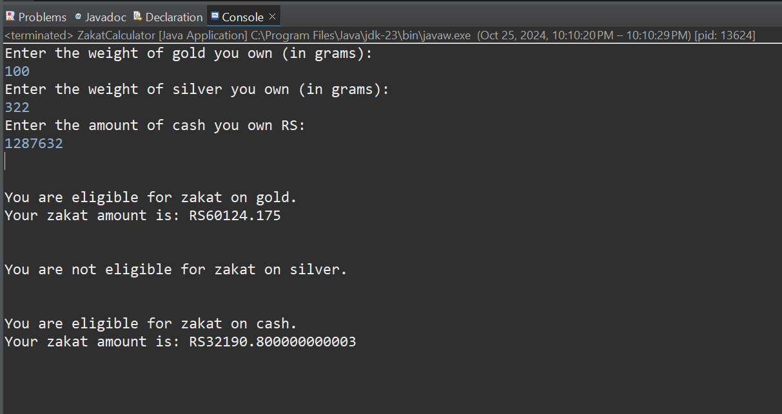

Task 02
2. Implement a car rental system using Naming conventions and follow Hungarian Notation as
standard. Include fields for car details, rental duration, and customer information and methods
for editing and printing these details.
package lab_5;
public class CarRentalSystem {
// Car details
private String strCarModel;
private int intCarYear;
private String strCarPlate;
// Rental details
private int intRentalDays;
// Customer details
private String strCustomerName;
private String strCustomerLicense;
// Constructor
public CarRentalSystem(String strCarModel, int intCarYear, String strCarPlate, int intRentalDays, String strCustomerName, String strCustomerLicense) {
this.strCarModel = strCarModel;
this.intCarYear = intCarYear;
this.strCarPlate = strCarPlate;
this.intRentalDays = intRentalDays;
this.strCustomerName = strCustomerName;
this.strCustomerLicense = strCustomerLicense;
}
// Method to edit car details
public void editCarDetails(String strNewCarModel, Integer intNewCarYear, String strNewCarPlate) {
if (strNewCarModel != null) {
this.strCarModel = strNewCarModel;
}
if (intNewCarYear != null) {
this.intCarYear = intNewCarYear;
}
if (strNewCarPlate != null) {
this.strCarPlate = strNewCarPlate;
}
System.out.println("Car details updated successfully.");
}
// Method to edit rental duration
public void editRentalDuration(int intNewRentalDays) {
this.intRentalDays = intNewRentalDays;
System.out.println("Rental duration updated successfully.");
}
// Method to edit customer details
public void editCustomerDetails(String strNewCustomerName, String strNewCustomerLicense) {
if (strNewCustomerName != null) {
this.strCustomerName = strNewCustomerName;
}
if (strNewCustomerLicense != null) {
this.strCustomerLicense = strNewCustomerLicense;
}
System.out.println("Customer details updated successfully.");
}
// Method to print car rental information
public void printRentalDetails() {
System.out.println("Car Model: " + this.strCarModel);
System.out.println("Car Year: " + this.intCarYear);
System.out.println("Car Plate: " + this.strCarPlate);
System.out.println("Rental Duration (Days): " + this.intRentalDays);
System.out.println("Customer Name: " + this.strCustomerName);
System.out.println("Customer License: " + this.strCustomerLicense);
}
// Main method to demonstrate functionality
public static void main(String[] args) {
// Initialize car rental details
CarRentalSystem rental = new CarRentalSystem("Toyota Camry", 2020, "XYZ123", 7, "John Doe", "D12345678");
// Print initial details
rental.printRentalDetails();
// Edit details
rental.editCarDetails("Honda Accord", 2021, "ABC789");
rental.editRentalDuration(10);
rental.editCustomerDetails("Jane Smith", "D87654321");
// Print updated details
rental.printRentalDetails();
}
}
